Design drug database architecture

The system architecture looks as follows:

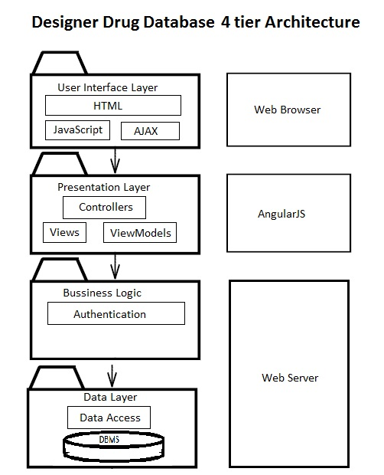

This is a 4 tier architecture that is divided in user interface layer, presentation layer, business logic and data layer.

The user interface layer is composed of html, JavaScript, AJAX. In this layer we will be using the bootstrap framework to create a responsive web design and a professional environment. The next layer is the presentation layer which is directly linked to AngularJS and describes the behavior of the previous layer. This layer contains the angular controllers, views, page-routing and other angular features. The next layer is the business logic, located in the Web Server. This layer takes care of authentication and authorization of different transactions. The next and last layer is the data layer, which consist of an API to retrieve the information from the database, given the proper authorization, and the database itself.